**Week 01-01:**

**Name:Snehan.S**

**Roll no:241801272**

**1.** This is a simple challenge to help you practice printing to stdout. We're starting out by printing the most famous computing phrase of all time! In the editor below, use either printf or cout to print the string Hello, World! to stdout.

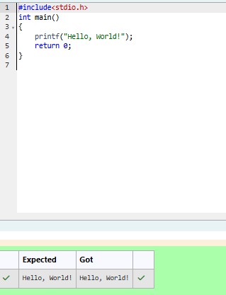

2. This challenge will help you to learn how to take a character, a string and a sentence as input in C. To take a single character ch as input, you can use scanf("%c", &ch); and printf("%c", ch) writes a character specified by the argument char to stdout:

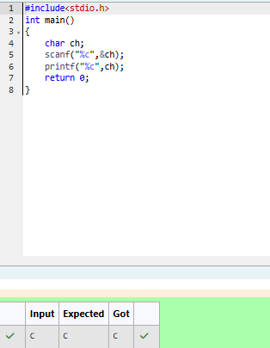

3. Write a program to input a name (as a single character) and marks of three tests as m1, m2, and m3 of a student considering all the three marks have been given in integer format. Now, you need to calculate the average of the given marks and print it along with the name as mentioned in the output format section. All the test marks are in integers and hence calculate the average in integer as well. That is, you need to print the integer part of the average only and neglect the decimal part.

